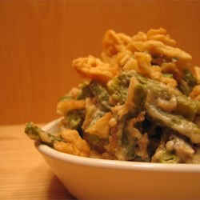
Grandma's Green Bean Casserole
Prep Time 15 minutes Cook Time 40 minutes

Ingredients
2 tablespoons butter
2 tablespoons all-purpose flour
1 teaspoon salt
1 teaspoon white sugar
1/4 cup onion, diced
1 cup sour cream
3 (14.5 ounce) cans French style green beans, drained
2 cups shredded Cheddar cheese
1/2 cup crumbled buttery round crackers
1 tablespoon butter, melted

Directions
- Preheat oven to 350 degrees F (175 degrees C).
- Melt 2 tablespoons butter in a large skillet over medium heat.
- Stir in flour until smooth, and cook for one minute.
- Stir in the salt, sugar, onion, and sour cream.
- Add green beans, and stir to coat.
- Transfer the mixture to a 2 1/2 quart casserole dish. Spread shredded cheese over the top.
- In a small bowl, toss together cracker crumbs and remaining butter, and sprinkle over the cheese.
- Bake for 30 minutes or until the top is golden and cheese is bubbly.

Notes
For Thanksgiving dinner, 2019, April omitted the onions and added some onion powder. She layered the cheddar cheese and beans in the casserole dish instead of just putting it on top.

